|  |  |
| --- | --- |
| **Title** | 4th homework in the Electric Circuit Theory class by 201923250 |

|  |  |  |  |
| --- | --- | --- | --- |
| **Author** | 201923250 | **Date** | 9.24.2020 |

**Summarization of chapters 8.5-8.7**

The phase answer is obtained as we learned in the previous chapter applying a dc source unexpectedly. Therefore, the function equation for the RLC series is not

Impairment of the dc root image. Note that *v* and *i* are the voltage through the condenser and current through the inductor respectively. The condenser is as accessible as the inductor functions as a short circuit. Strom may not adjust temporarily via the inductor the same current through the inductor and condenser the condenser is in sequence now. The source of voltage is zero, so it functions like a short circuit. We are prepared to extend these ideas to any second-order circuit with one or more separate, constant-value sources. At first, a circuit can appear complex. But until the sources are switched off, it can be reduced either to a first-order circuit, where the storage elements can be merged, or to an RLC circuit in parallel / series. This general technique is extended to find the phase reaction of any second-order circuit, including those with op amplifiers.

**Example Problems with explanations**

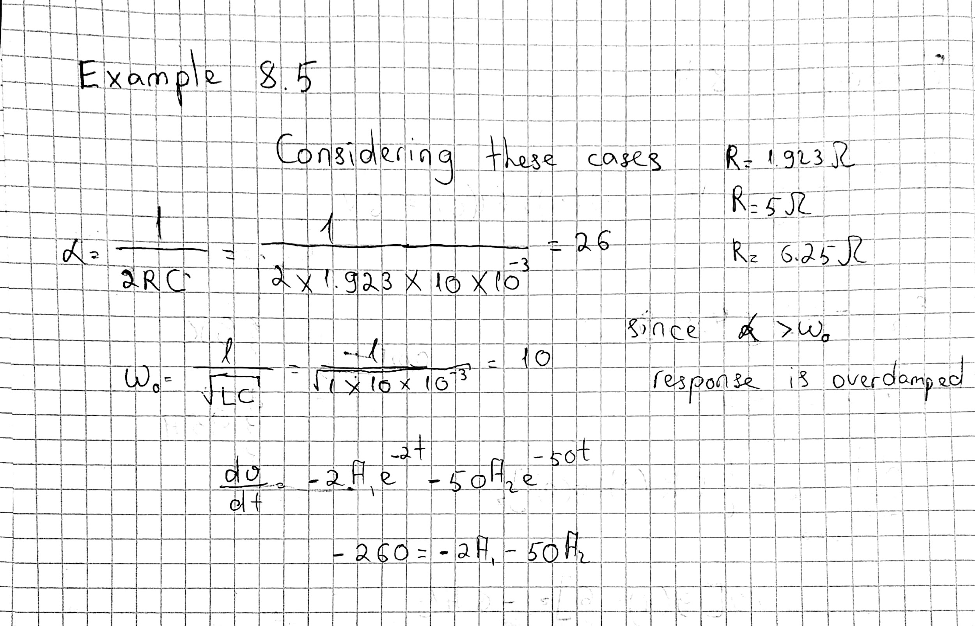

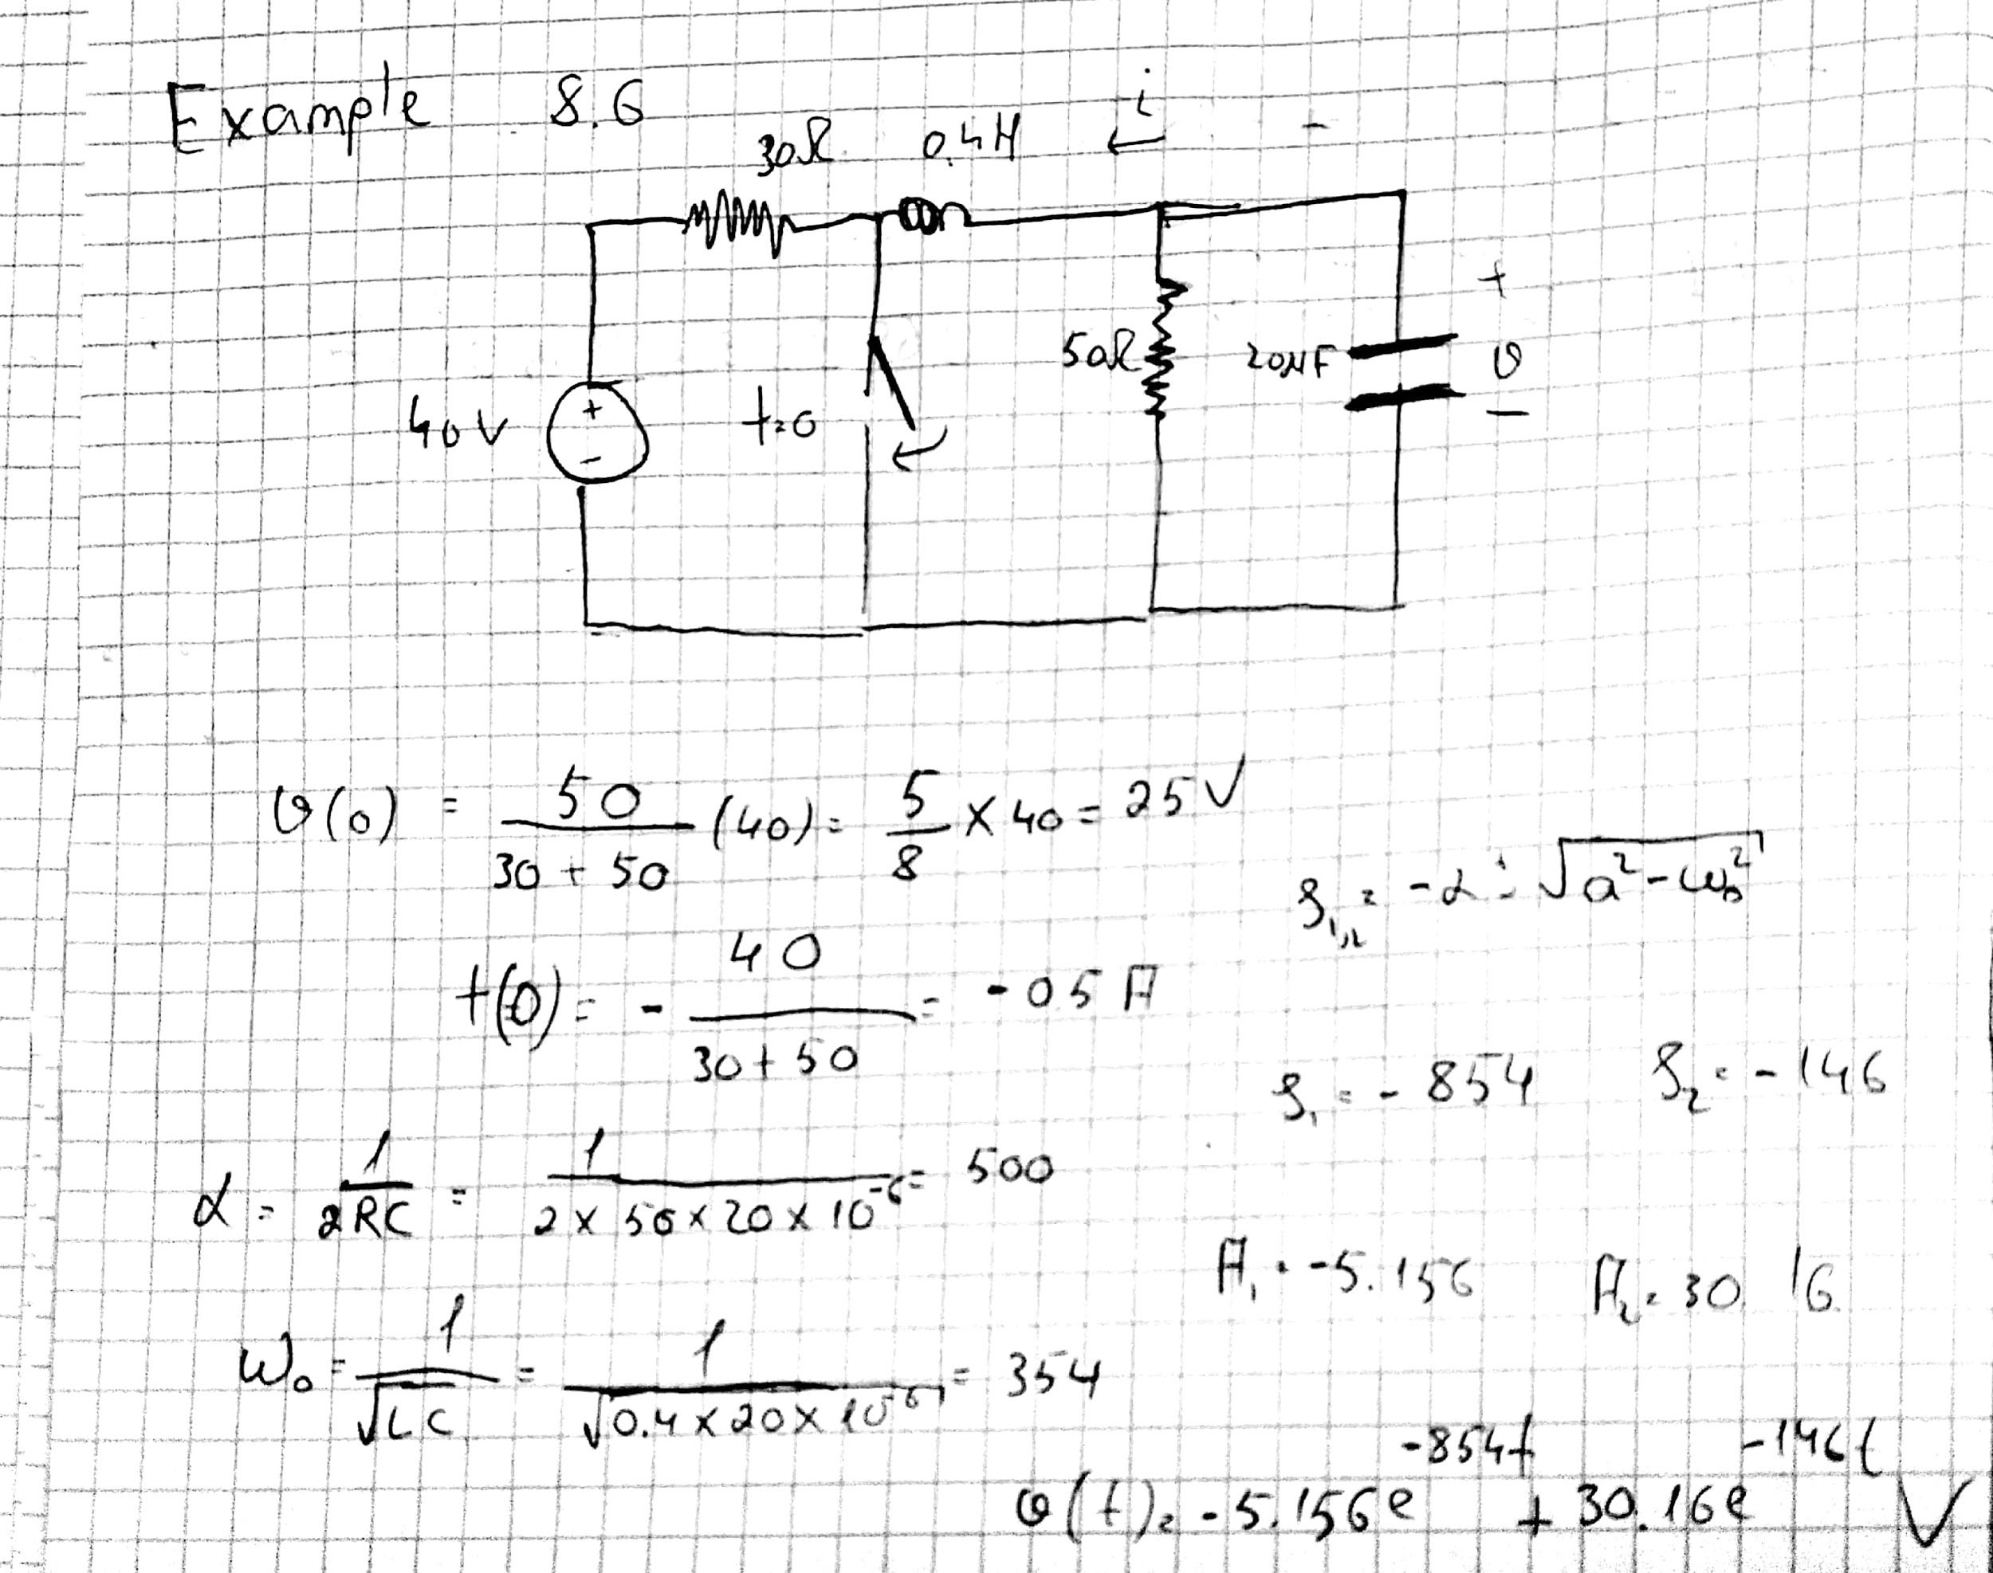

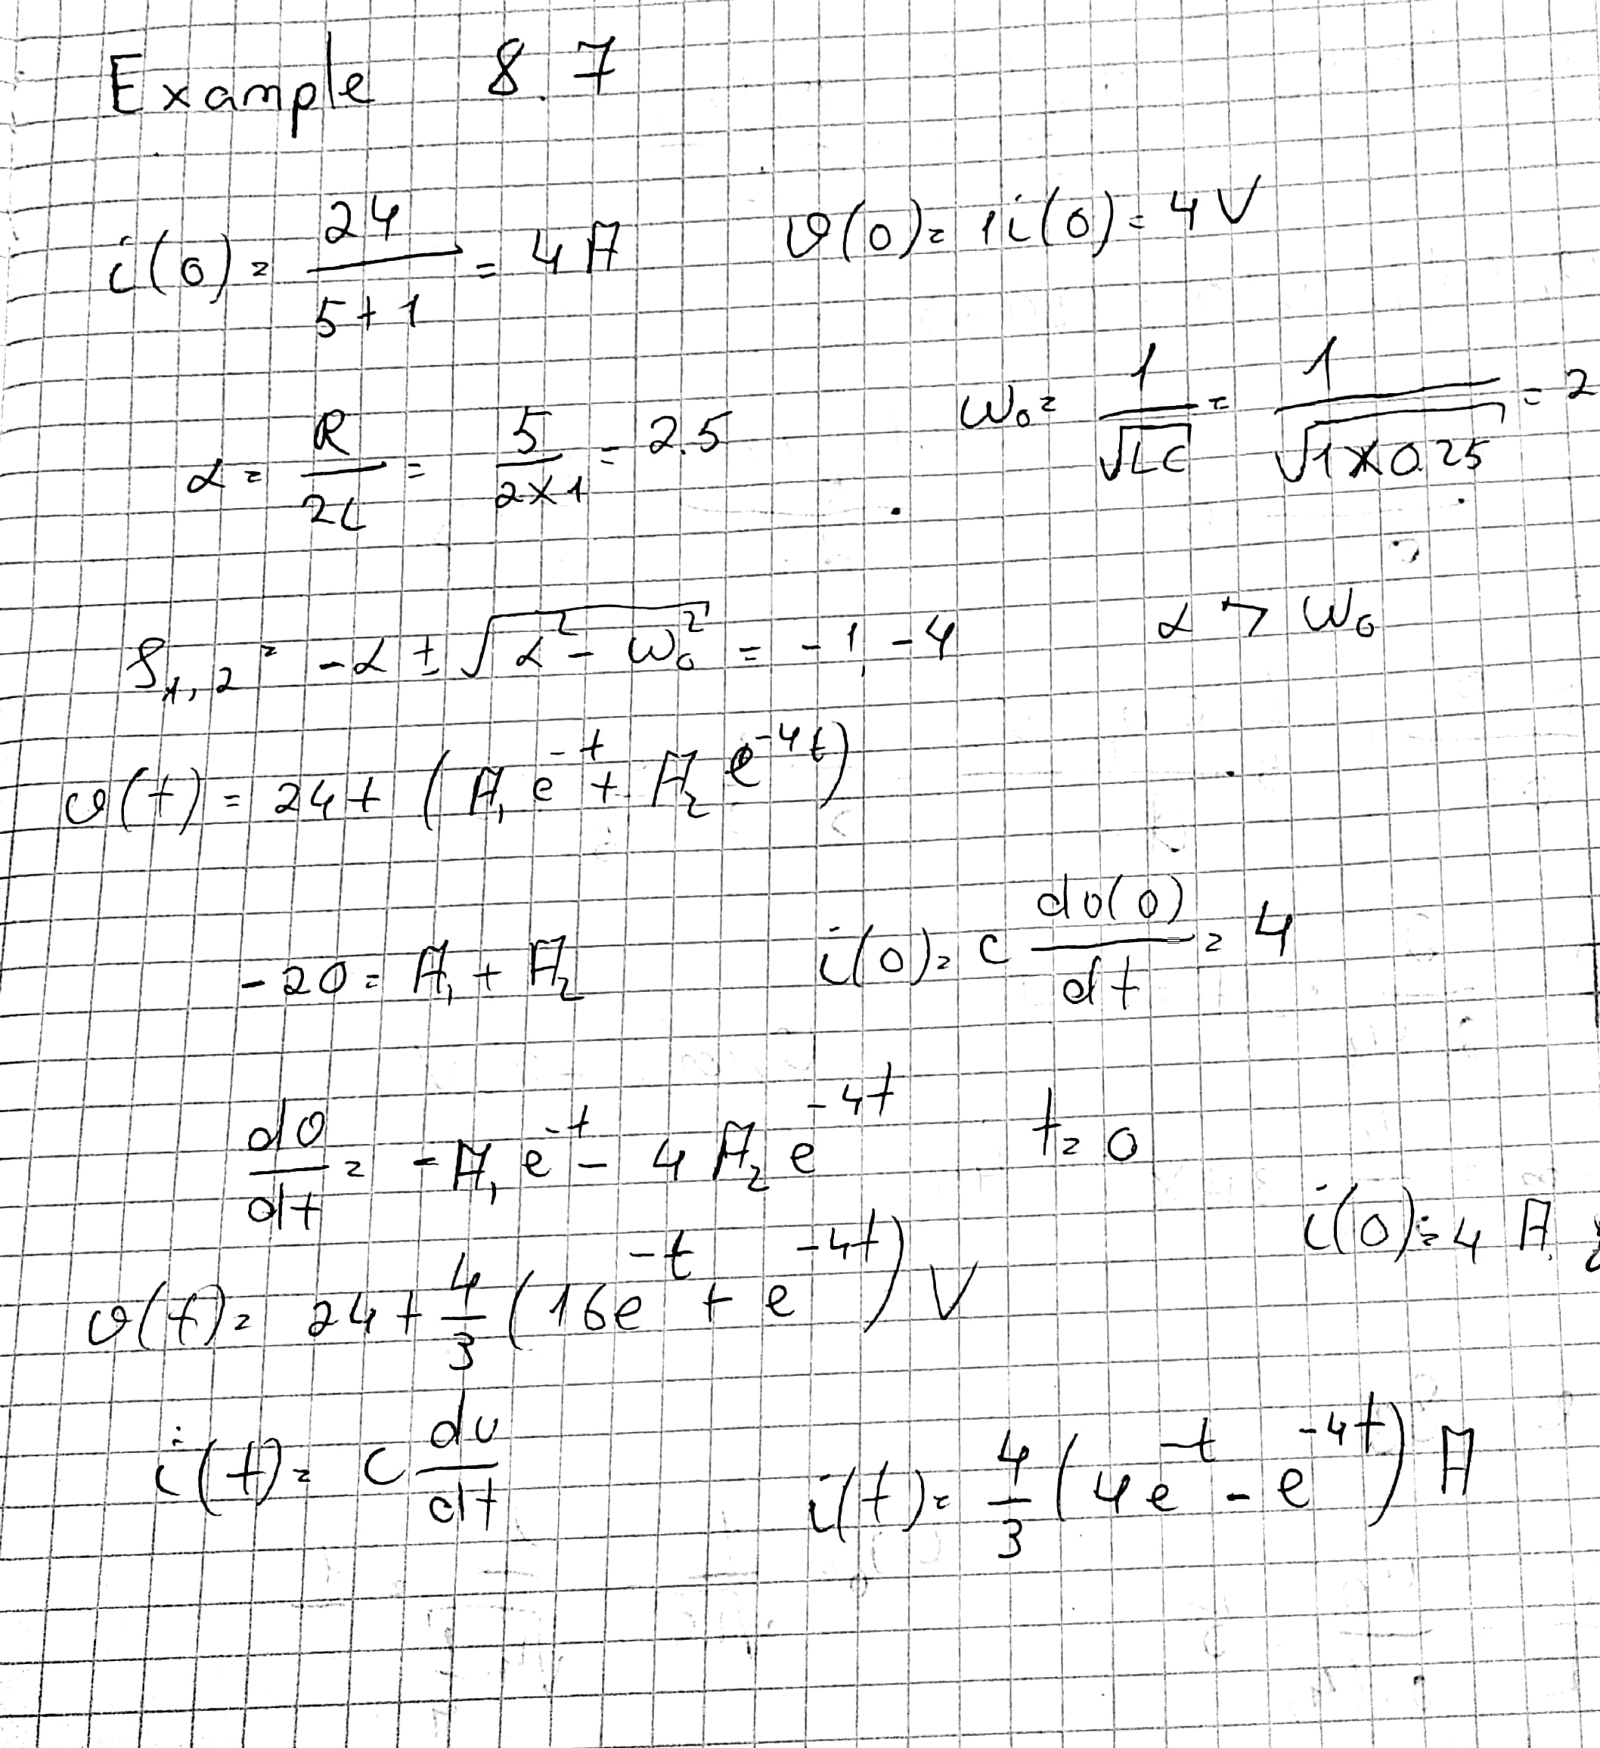

Thank you

Student ID : 201923250

Name : Kobilov Ilkhomjon